**ASSIGNMENT 1**

**Name – Hritik Ray**

**Install GIT & make sure it is added into PATH.**



1. **Create a directory ‘project_dir’ & cd to ‘project_dir’.**

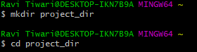

1. **Initialize git version database. (git init)**



1. **Create a new file index.html.**



1. **Check the git status. You should find index.html as untracked file**

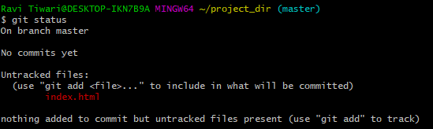

1. **Stage the index.html file.**

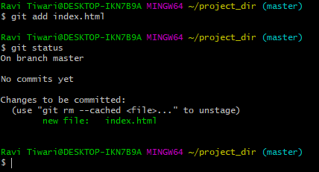

1. **Commit index.html**

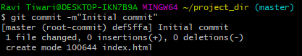

1. **Make few changes in index.html & create a new file info.txt file.**

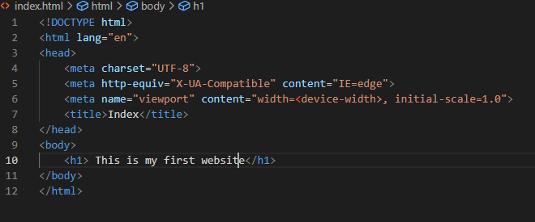

**New file created**



1. **Check git status. You should find index.html & info.txt as untracked files**

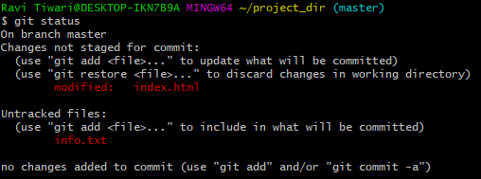

1. **Configure GIT to ignore all txt files.**

**Created new file**



**Used *txt in the gitignore file to not include text using vscode**

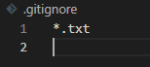

**Added .gitignore into the staging area**

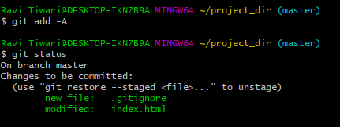

**Commited .gitignore**

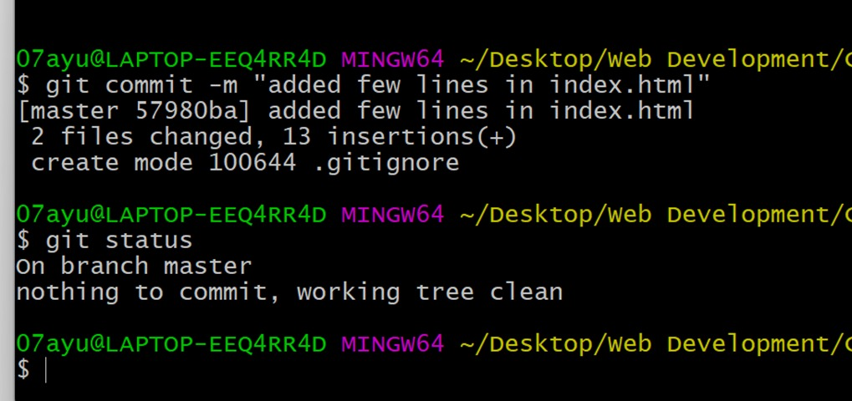

1. **Again check the git status. You should find only index.html as untracked file**

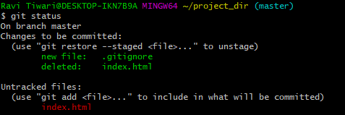

1. **Stage & commit index.html**

**Staged index.html**

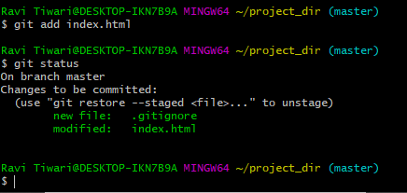

**Committed index.html**

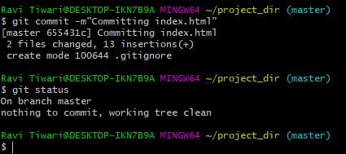

1. **Log all your comments so far**

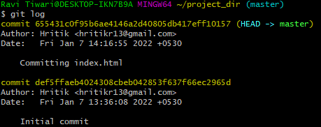

1. **Make some changes in index.html.**

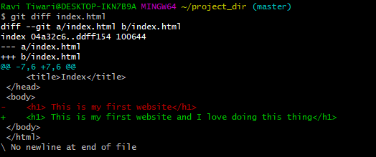

1. **Revert the change made in the previous step using git command.**

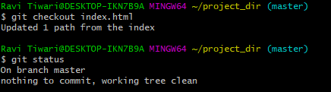

**changes reverted back in vscode**

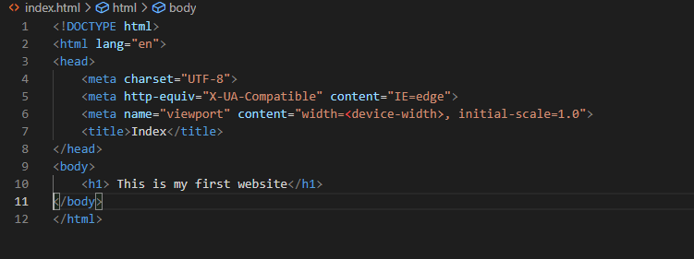

1. **Again change index.html.**

**Again made changes in index.html**

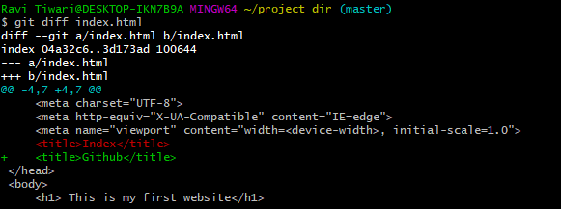

1. **Stage index.html**

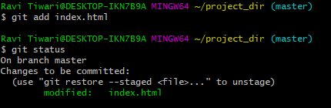

1. **Revert back the last stage.**

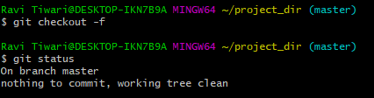

1. **Rename ‘add’ command to ‘my-add’.**



1. **Using my_add command Stage index.html again & commit the changes**

**Staging index.html using my-add**

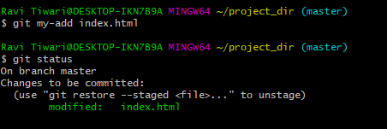

**Committing the changes**

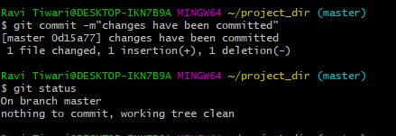

1. **Revert the last commit.**

